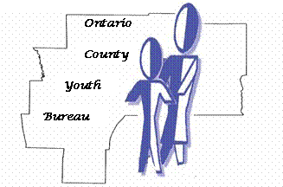

ONTARIO COUNTY

YOUTH BOARD

2022 MEETINGS

Tuesday, January 25, 2022
Tuesday, March 1, 2022
(Presenter: Geneva Community Health/Repro Education & Outreach)
Tuesday, March 22, 2022
(Presenter: Partnership for Ontario County)
Tuesday, April 26, 2022
Tuesday, June 7, 2022
Tuesday, June 28, 2022
Tuesday, July 26th
Keep July date available for Allocation
No Meeting in August
Tuesday, October 4, 2022
Tuesday, October 25, 2022
Tuesday, November 15, 2022
Tuesday, December 13, 2022

All meetings are scheduled for the fourth Tuesday of the month and begin at 5:00 unless otherwise noted … highlighted dates indicate change in date, time, and/or location …see below:

Please note that May’s meeting will be held in June to avoid AP Exams and June’s meeting will be our picnic; location to be determined; November and December are earlier dates due to Thanksgiving and Christmas.

All regularly scheduled meetings except the picnic will be held via WebEx until further notice.

Picnic location to be determined.

