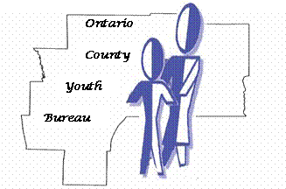

ONTARIO COUNTY

YOUTH ADVISORY BOARD

2020 MEETING SCHEDULE

January 28th

February 25th

March 24th

April 21st (FLCC Canandaigua Campus, 4:00 pm to 9:00 pm)

May 26th

June 23rd (Annual Picnic at Kershaw Park)

July (No Meeting)

August 25th (No Meeting)

September 22nd

October 27th

November 24th

December 15th

All meetings are scheduled for the fourth Tuesday of the month and begin at 5:30 unless otherwise stated.

All meetings are to be held at the Human Services Building (3010 County Complex Drive) in Conference Room 8 unless otherwise stated.

